**Search Parameters**

**Purpose:**

The purpose of this document is to outline the Search form and map the available search fields and map to the database table and column they correspond to. The database table name is needed to generate the appropriate sql table modifiers to attach to a statement.

(Example: SELECT a.root, b.wordform FROM root AS a INNER JOIN words AS b ON a.rootID = b.rootID WHERE b.gloss ILIKE ‘%dog%’;)

With out knowing the tables where the corresponding fields are in, the query will not execute or return bad data.

Do we want to generate an array that contains key 🡪 value pairs of *TABLENAME* 🡪 *FIELDLABEL* and then cycle through the array to get the appropriate tables and modifiers to dynamically inject into the query where needed.

It would be efficient to name the form fields (name or id) the actual db column name they correspond to. Then we do not have to translate the form fields into db columns. This should be done for all forms that contain db data. This convention will benefit the UPDATE and INSERT statements as well.

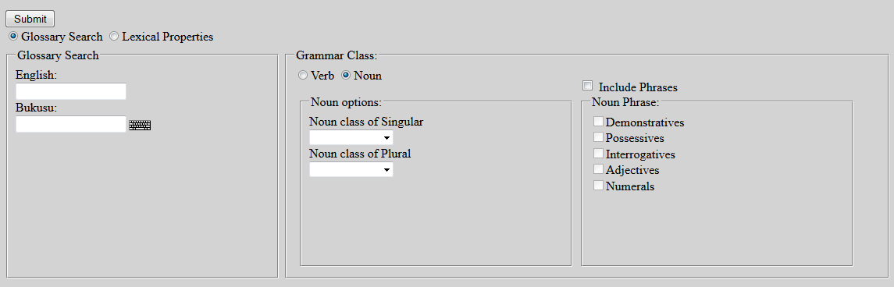

**Section: Glossary Search**

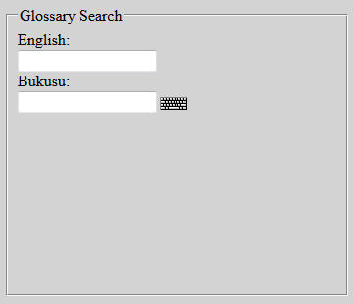

Enrollment in local colleges, 2005

| Field Label | Field Name | DB Table | Table Column |
| --- | --- | --- | --- |
| English |  | words | Gloss |
| Bukusu |  | root | Root |
|  |  | words | wordform |

**Section: Lecical Properties**

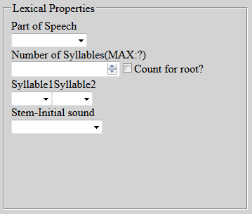

| Field Label | Field Name | DB Table | Table Column |
| --- | --- | --- | --- |
| Part of Speech |  | words | pos |
| Number of Syllables |  | words | numOfSyllables |
| Syllable 1 |  | ??? | ??? |
| Syllable 2 |  | ??? | ??? |
| Stem-Initial Sound |  | root | initialSound |
|  |  | words | initialSound |

**Section: Grammar Class**

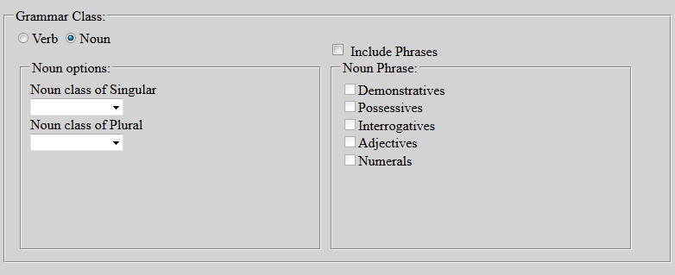

| Field Label | Field Name | DB Table | Table Column |
| --- | --- | --- | --- |
| Verb |  | words | pos |
| Noun |  | words | pos |

**Section: Grammar Class 🡪 Noun Options**

| Field Label | Field Name | DB Table | Table Column |
| --- | --- | --- | --- |
| Noun class of Singular |  | words | subPos |
| Noun Class of Plural |  | words | subPos |

**Section: Grammar Class 🡪 Noun Phrase**

| Field Label | Field Name | DB Table | Table Column |
| --- | --- | --- | --- |
| Demonstratives |  | phrasal_data | modifier1 |
|  |  |  | modifier2 |
| Possessives |  | phrasal_data | modifier1 |
|  |  |  | modifier2 |
| Interrogatives |  | phrasal_data | modifier1 |
|  |  |  | modifier2 |
| Adjectives |  | phrasal_data | modifier1 |
|  |  |  | modifier2 |
| Numerals |  | phrasal_data | modifier1 |
|  |  |  | modifier2 |

**Section: Grammar Class 🡪 Verb Options**

| Field Label | Field Name | DB Table | Table Column |
| --- | --- | --- | --- |
| High |  | words | tonalPattern |
| Low |  | words | tonalPattern |
| Reflexive |  | words | subPos |
| Reciprocal |  | words | subPos |

**Section: Glossary Search 🡪 Verb Phrase**

| Field Label | Field Name | DB Table | Table Column |
| --- | --- | --- | --- |
| Tense |  | ??? | ??? |
| Aspect |  | ??? | ??? |
| Progressive |  | phrasal_data | modifier1 |
|  |  |  | modifier2 |
| Adverb’s |  | phrasal_data | modifier1 |
|  |  |  | modifier2 |
| Passive |  | phrasal_data | modifier1 |
|  |  |  | modifier2 |
| Perfective |  | phrasal_data | modifier1 |
|  |  |  | modifier2 |